**UNIVERSITY-BANGLADESH**

**Faculty of Science and Technology**

**Experiment 3**

|  |  |  |  |  |
| --- | --- | --- | --- | --- |
| Assignment Title: | Familiarization with Visual Designer for Arduino™ AVR and Raspberry Pi and implementation of a traffic control system using Drag -Drop -Play. | | | |
| Assignment No: | 03 | | Date of Submission: | 7 October 2021 |
| Course Title: | Microprocessor And Embedded Systems | | | |
| Course Code: | EEE 4103 | | Section: | M |
| Semester: | Fall | 2021-22 | Course Teacher: | **Dr. Ferdous Jahan Shaun** |

**Declaration and Statement of Authorship:**

1. I/we hold a copy of this Assignment/Case-Study, which can be produced if the original is lost/damaged.
2. This Assignment/Case-Study is my/our original work and no part of it has been copied from any other student’s work or from any other source except where due acknowledgement is made.
3. No part of this Assignment/Case-Study has been written for me/us by any other person except where such collaboration has been authorized by the concerned teacher and is clearly acknowledged in the assignment.
4. I/we have not previously submitted or currently submitting this work for any other course/unit.
5. This work may be reproduced, communicated, compared and archived for the purpose of detecting plagiarism.
6. I/we give permission for a copy of my/our marked work to be retained by the Faculty for review and comparison, including review by external examiners.
7. I/we understand thatPlagiarism is the presentation of the work, idea or creation of another person as though it is your own. It is a formofcheatingandisaveryseriousacademicoffencethatmayleadtoexpulsionfromtheUniversity. Plagiarized material can be drawn from, and presented in, written, graphic and visual form, including electronic data, and oral presentations. Plagiarism occurs when the origin of them arterial used is not appropriately cited.
8. I/we also understand that enabling plagiarism is the act of assisting or allowing another person to plagiarize or to copy my/our work.

*\* Student(s) must complete all details except the faculty use part.*

** Please submit all assignments to your course teacher or the office of the concerned teacher.

|  |  |
| --- | --- |
| Group Name/No.: | B |

|  |  |  |  |  |
| --- | --- | --- | --- | --- |
| **No** | **Name** | **ID** | **Program** | **Signature** |
| 1 | Nurul Huda Bhuiyan Rokon **(Author)** | 18-38983-3 | BSc [CSE] |  |
| 2 | Tonima Hossain Pia **(Author)** | 18-38892-3 | BSc [CSE] |  |
| 3 | Durjoy Dey | 18-39013-3 | BSc [CSE] |  |
| 4 | Ananya Chowdhury | 18-39028-3 | BSc [CSE] |  |
| 5 | Joy Karmakar | 18-39263-3 | BSc [CSE] |  |
| 6 | Sazid Al Farabi | 19-39478-1 | BSc [CSE] |  |
| 7 | Sharika Parvin Joba | 18-38721-3 | BSc [CSE] |  |
| 8 | Salma Jahan Sahara | 18-38788-3 | BSc [CSE] |  |
|  |  |  |  |  |

|  |  |  |
| --- | --- | --- |
| ***Faculty use only*** | | |
| FACULTYCOMMENTS | **Marks Obtained** |  |
|  |
|  |
|  | **Total Marks** |  |
|  |
|  |

Contents

Abstract: 4

Objectives: 4

Results: 4

1) Simulation Environment: 5

2) Simulation Results: 5

3) Discussion on Simulation Results: 13

Lab Task Question: 13

Conclusion: 13

Reference(s): 14

# 

# 

# Abstract:

The main goal of this experiment is to build an LED flashing and traffic control system using Arduino and Raspberry PI. We must first become familiar with Arduino. Arduino offers a variety of boards, each with its own set of features. Arduino is an open-source platform that allows you to create interactive electrical creations. The Raspberry Pi is a low-cost, credit-card-sized computer that connects to a computer monitor or television and can be controlled with a conventional keyboard and mouse. We'll create a traffic management system here. Using the Animated LED model, the LED will blink. There will be three different LED variants available. Red, yellow, and green are just a few of the hues available. We'll also include a delay option to aid with flashing the lights during specific times. We'll also implement a delay function, which will allow the lights to flash at predetermined intervals. For this exercise, we'll use an Arduino Uno and a Raspberry Pi to create a simple traffic control design. For our simulation, we will use the proteus software. As a result, we will have a simulation result for a traffic control system. It will become a traffic control system after this experiment is completed.

# Objectives:

# This experiment will teach us how to build a traffic management system with an Arduino Uno and a Raspberry Pi, as well as how to use Proteus 8.9 Professional software as a simulation environment. We can learn how to make the LED blink using Arduino and the Raspberry Pi in this experiment. We can learn about microcontrollers as well. We require a microcontroller because any input sent via keyboard necessitates the employment of a microcontroller. We will manage and control the traffic control system using these methods.

# Results:

## Simulation Environment:

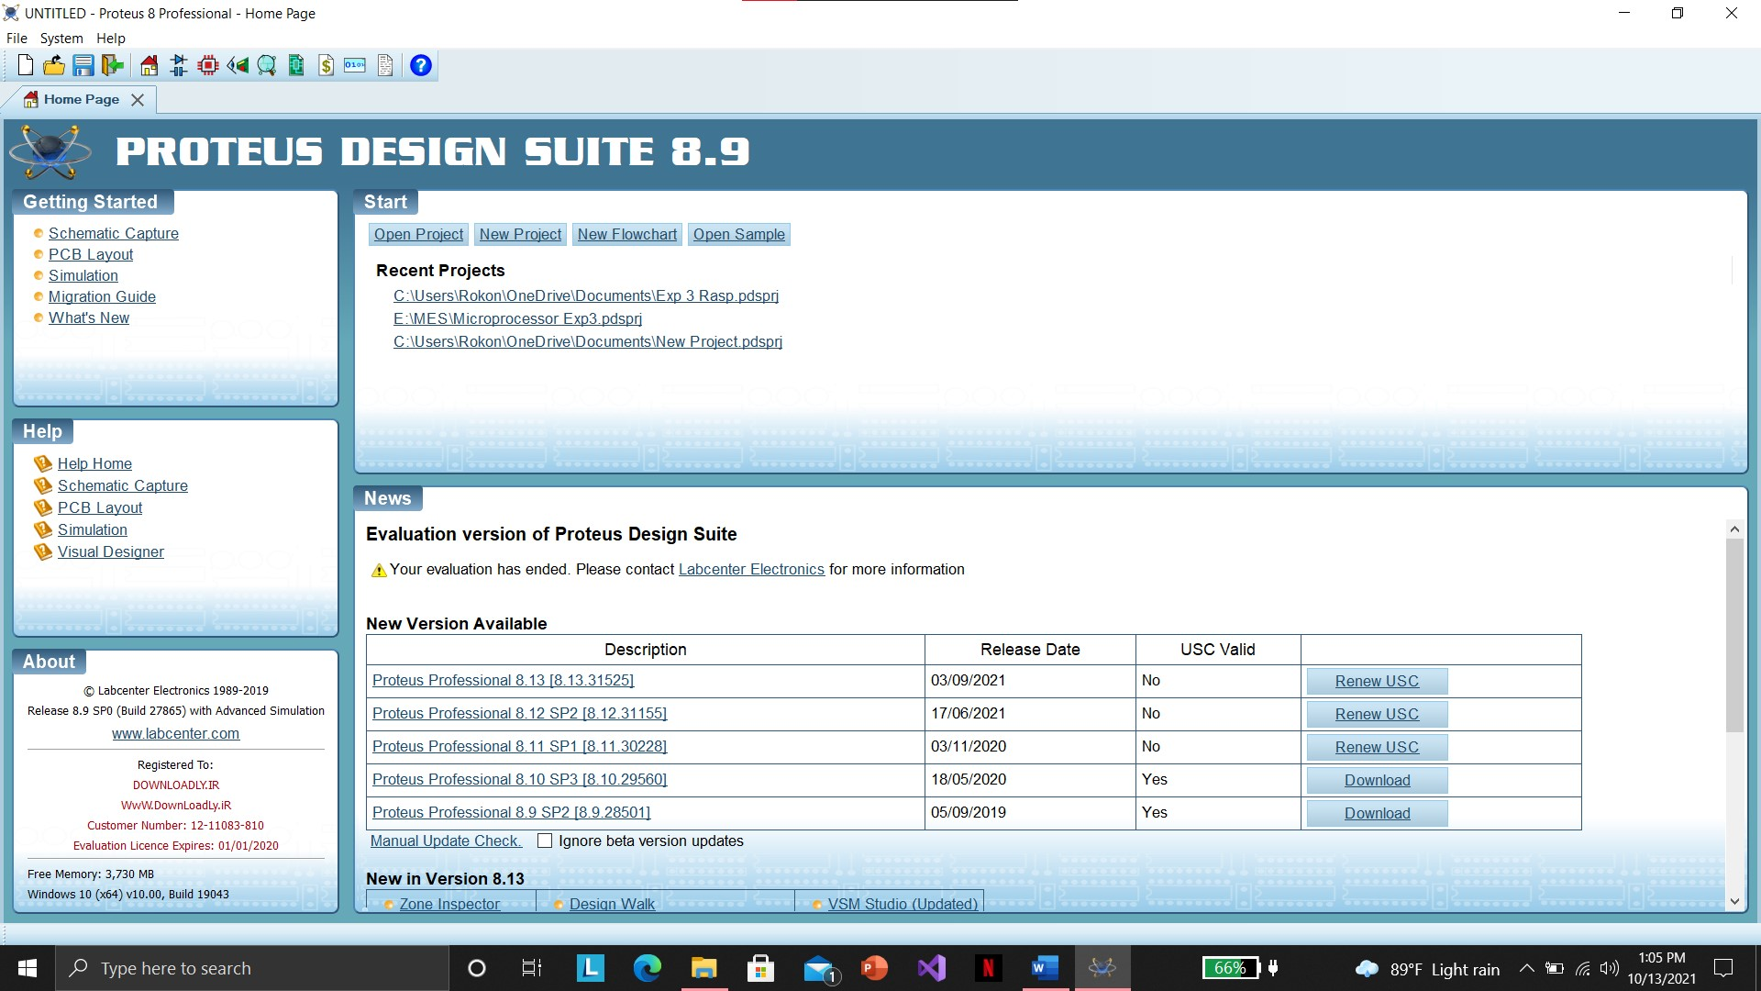

Figure 1: Proteus UI

fdfdfdfdd

We utilized Proteus 8 Professional software to simulate this experiment. This is the software user interface for Proteus 8.9.

## Simulation Results

**Adruino Uno**

|  |
| --- |
| Figure 2:Visual Designer |
| Figure 3: RED LED |
| Figure 4:Yellow LED |
| Figure 5: Green LED |
| Figure 6: Red light on |
| Figure 7: Yellow Light On |
| Figure 8: Green Light On |

**Raspberry Pi**

|  |
| --- |
| Figure 9:Visual Designer |
| Figure 10:Red LED |
| Figure 11:Yellow LED |
| Figure 12:Green LED |
| Figure 13:RED Light is on |
| Figure 14: YELLOW light is on |
| Figure 15: Green Light is on |

## 3) Discussion on Simulation Results:

The simulation results were done using Proteus 8.9 Professional software by implementing a traffic control system using Arduino UNO and Raspberry PI. At First, open the Visual designer and add three parapharels(RED, YELLOW, GREEN LED) and then draw the chart and build the designer. After building the designer we compile the schementhic designer.

# 

# Lab Task Question:

1) Modify the design for Two Way Traffic Light System

# Conclusion:

At first, we have design the circuit using Arduino Uno. In visual designer we have taken three(Red,Yellow, Green) LED. Red led will blink for 10 sec then off. Yellow Led will blink for 5 sec then dim at 60 brightness for 2 sec before turning off. Green led will blink for 12 sec then goes off. Three will on and off simultaneously. Then we will design the circuit using Raspberry PI. All the process will be repeated but we’ll exclude dim function from yellow led then compile the designer.

# Reference(s):

**1)**[**https://www.arduino.cc/**](https://www.arduino.cc/)**.**

**2)** [**https://www.labcenter.com/visualdesigner/**](https://www.labcenter.com/visualdesigner/)

**3)**[**https://youtu.be/yHB5it0s2oU**](https://youtu.be/yHB5it0s2oU)

**4)** **https://www.raspberrypi.org**